 | NCC Activities 2022-23
S.No | Date | Activity | No of the cadets participated
1. | 21/06/22 | 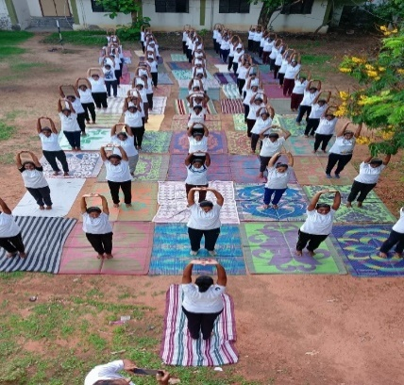  YOGA DAY | 75
2. | 08/07/22 | 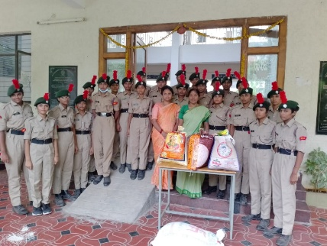  Adharana shelter (Rice & cloth donation) | 16
3. | 13/08/22 To 15/08/22 | 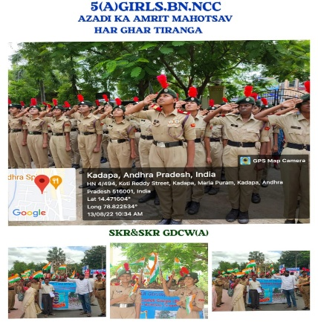  HAR GHAR THIRANGAR | 80
4. | 15/08/22 | 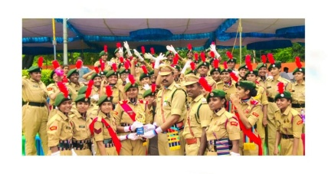  POLICE GROUND PARADE | 26
5. | 08/08/22 | NCC FAREWELL  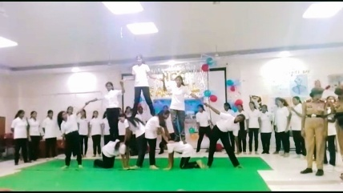  PYRAMIDS | 30
6. | 08/08/22 | 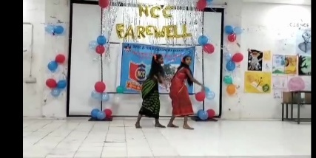  FLOK DANCE | 03
7. | 08/08/22 | 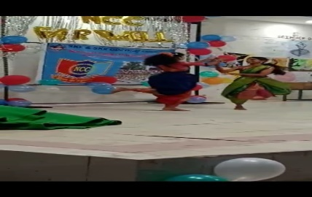  DANCE | 03
8. | 08/08/22 | Singing  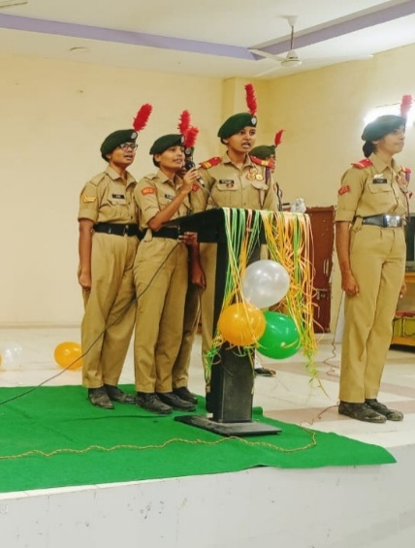 | 02
9. | 08/08/22 | Patriotic dance  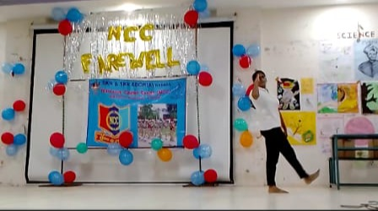 | 1
10. | 25/11/22 | FLAG DAY  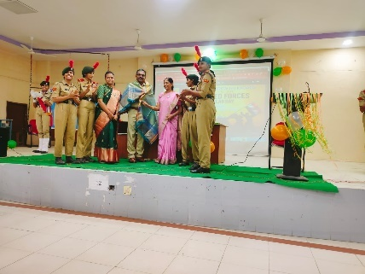  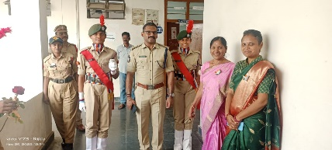 | 75
10. | 26/11/22 | 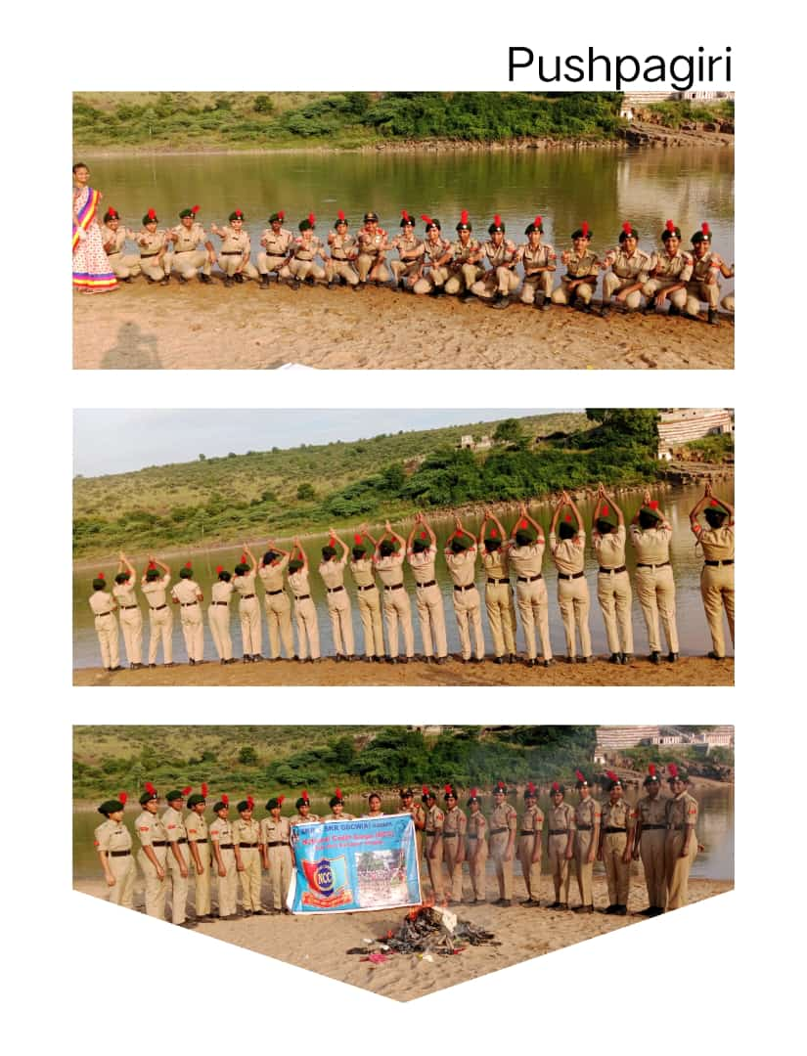  PUNEETH SAGAR ABHIYAN | 23
11. | 01/12/22 | 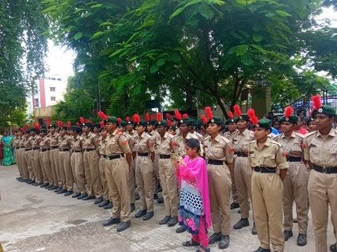  AIDS DAY RALLY | 50
12. | 23/02/2023 | G-20 Summit Awareness program  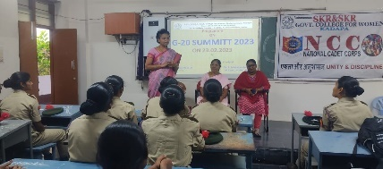 | 55

 |  | NCC- Camp details 2022-23
S.No | Date | Camp Name | No of the cadets participated | Name of the cadets who participated
1. | 17/10/21 To 26/10/21 | IGC-RDC(TIRUPATI) | 01 | K.BHANUSREE
2. | 18/12/21 To 24/12/21 | ATC-SECUNDRABAD | 01 | P.BHAVITHA KEERTHI
3. | 31/01/22 To 06/02/22 | CADRE CAMP | - B cadets -41  - C cadets -47
4. | 03/05/22 To 11/05/22 | MALVANAKAR | 02 | K.BHANUSREE  A.CHANDHANA
5. | 18/05/22 To 27/05/22 | CATC-1(TIRUPATI) | - B cadets -45  - C cadets -39
6. | 13/06/22 To 22/06/22 | CATC-3(TIRUPATI) | 02 | 1. K.SWETHA  2. K.LAKSHMI DEVI
7. | 25/06/22 To 04/06/22 | CATC-4(30BN KADAPA) | 10 | 1. P.BHAVITHAKEERTHI  2.K.BHANUSREE  3.G.MAMATHA  4.D.MANASA  5.M.PAVANA KUMARI  6.M.SUPRIYA  7.R.INDHU  8.Y.GANGOTHRI  9.T.RAJITHA  10.D.NIREEKSHANA
8. | 06/07/22 To 15/07/22 | CATC-5(35BN CHITHOOR) | 05 | 1.G.MAMATHA  2.M.PAVANA KUMARI  3.Y.GANGOTHRI  4.T.RAJITHA  5.D.NIREEKSHANA
9. | 16/07/22 To 25/07/22 | CATC-6(29BN TIRUPATI) | 05 | 1.G.MAMATHA  2.M.PAVANA KUMARI  3.Y.GANGOTHRI  4.T.RAJITHA  5.D.NIREEKSHANA
10. | 25/07/22 To 03/08/22 | TSC(IGC)-CHIRALA | 04 | 1.G.MAMATHA  2.Y.GANGOTHRI  3.T.RAJITHA  4.D.NIREEKSHANA
11. | 29/08/22 To 05/09/22 | CATC-7(TIRUPATI) | 30
12. | 27/10/22 To 03/11/22 | CATC-8(35BN CHITHOOR) | 14
13. | 06/11/22 To 13/11/22 | CATC-9(35BN CHITHOOR) | 09 | 1.G.MAMATHA  2.K.NAVYA SREE  3. SK.AYESHA  4.A.CHANDHANA  5.Y.VANDHANA  6.G.KUSUMA LATHA  7.G.NEERAJA  8.K.LAKSHMI DEVI  9.M.SRAVANTHI
14. | 16/11/22 To 23/12/22 | RDC(IGC)-TIRUPATI | 09 | 1.G.MAMATHA  2.K.NAVYASREE  3. SK.AYESHA  4.A.CHANDHANA  5.Y.VANDHANA  6.G.KUSUMA LATHA  7.G.NEERAJA  8.K.LAKSHMI DEVI  9.M.SRAVANTHI
16. | 06/12/22 To 13/12/22 | PRE RDC(SECUNDRABAD) | 01 | G.KUSUMA LATHA
17. | 01/12/22 To 10/12/2 | SNIC(JAISALMER) | 02 | 1.Y.VANDHANA  2. SK.AYESHA

 | NCC Cadets Achievements 2022-23
S.No | Date | Achievement | Cadet Name
1. | 15/08/22 | 2nd prize in the parade on police ground | - NUMBER OF CADETS ATTEND-26

